**Abstract –**

High throughput sequencing has greatly improved our ability to investigate the evolutionary history of species using detailed demographic models. A popular approach for inferring parameters in these demographic models is by sampling genealogical histories at many short unlinked loci using a Markov chain Monte Carlo algorithm, e.g., IMa (Hey and Nielsen, 2007), BP&P (Yang and Rannala, 2010), and G-PhoCS (Gronau et al, 2011). The use of explicit coalescent models by these methods makes them powerful for inferring demographic parameters, but they are limited in their ability to assess the fit of the inferred model to data. We propose a novel and flexible statistical measure for model fit that is based on Bayes factors estimated using the samples generated by the MCMC algorithm. This method takes advantage of the strength of existing demography inference methods in exploring the space of plausible genealogies, and can be implemented through very minor adjustments to the existing source code and no modifications to the sampling algorithm itself.

**Demography Inference Methods and G-PhoCS**

Demography inference methods typically take in sequence data *X* from a collection of individuals from closely related populations and a parameterized demographic model *M*, and they infer values of parameters *Θ* in that model. Bayesian methods achieve this by assuming some prior distribution on the model parameters *P(Θ|M)* and sampling parameter values from an approximate posterior distribution *P(Θ|M, X*). Because the joint probability distribution *P(X , Θ|M)* cannot be efficiently computed, this task is often done by introducing hidden variables *G* to the model, such that the probability *P(X , G, Θ|M)* can be efficiently and accurately computed, and employing a Monte-Carlo Markov-Chain (mcmc) sampling algorithm for *G* and *Θ*. Sampling by mcmc guarantees that *(Θ, G)* will be sampled from a probability distribution approximating the posterior–*P(Θ, G|X , M)*. From this distribution one can extract approximate posterior means and credible intervals for all demographic parameters.

G-PhoCS is one such Bayesian demography inference method. Given sequence data, i.e. a small collection of unphased genomes at tens of thousands of short unlinked neutrally evolving loci , and given a population phylogeny model, G-PhoCS infers parameters *Θ* such as population divergence times 𝜏, ancestral population sizes θ and rates of post-divergence gene flow *m*. This is accomplished using an mcmc sampling of local genealogies jointly with model parameters according to an approximate posterior distribution for full Bayesian inference.

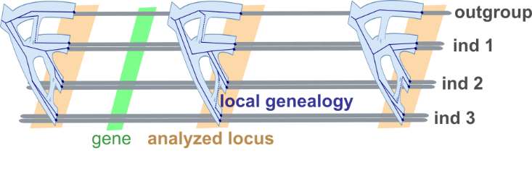

Fig 1 - G-PhoCS analyzing neutrally evolving loci

In each Markovian iteration, G-PhoCS uses the likelihood function [I] in a Monte Carlo coin toss, deciding whether to accept or reject the current sampling of genealogies and model parameters. $P[Θ]$ is the priori probability of model parameters to take current values. $P[G_{l}|Θ]$ is the probability of the genealogy in locus $l$ given the model parameters. It is calculated under the Kingman’s Coalescent Model, with special regard to migration events. $P[X_{l}|G_{l}]$ is the local data likelihood given the genealogy in locus $l$. It is calculated assuming a constant rate mutation model. G-PhoCS assumes no recombination events across loci, therefore likelihoods across loci are independent -

[I]

$$P\left[Θ, \left\{G_{l}\right\}, \left\{X_{l}\right\} | M\right]= P\left[Θ\right]⋅\prod_{l=1}^{L}{P\left[G_{l} | Θ, M\right]P[}X_{l}\left|G_{l}\right]$$

*Sequence data*

*Parameterss*

Fig 2 - Complete Likelihood Function used by G-PhoCS

**The Model Comparison Problem**

More fundamental in the field of computational biology is the **model comparison problem**. The problem tackles the comparison of phylogenetic topologies, also known as population or demographic models. It is best stated as follows –

*Given sequence data of samples from relative populations, which of the candidate phylogenetic topologies best fits the data?*

The model comparison problem aims to compare the fit to sequence data between a collection of structural models. It makes the distinction between structural components of model M (tree topology, migration bands, restriction on parameters) and parameter values $Θ$ (migration rate, divergence time, population size). What model comparison aims to do is to compare different ‘model structures’.

Figure 3 shows an illustration of aligned unphased full sequence data of individuals from populations a, b & c. Figure 4 shows an example comparison between models A & B. In model A, populations a and b are siblings and there is a constant migration rate across loci from population c to b. In model A populations b and c are siblings (instead of a and b) and there is no migration.

~~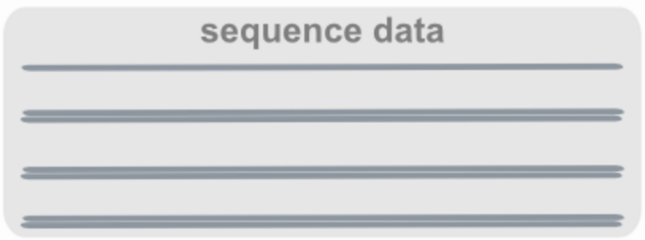~~

Fig 3 - Input sequence data

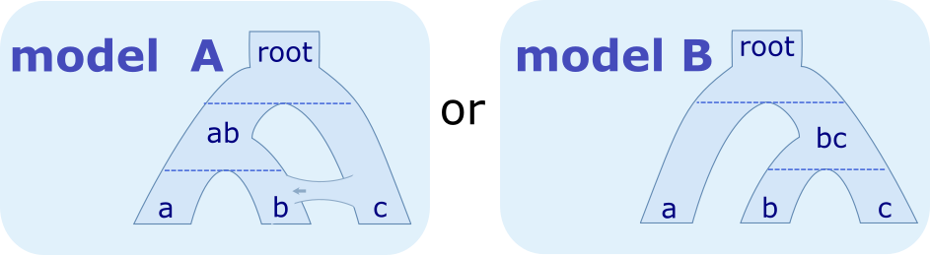

Fig 4 - Two feasible models MA & MB without Parameters Θ

Existing demography inference methods, as described in the introduction, are incapable of directly calculating the data to model likelihood - $P(X|M)$, with or without parameters $Θ$. The consequence is that researchers are unable to efficiently test many model hypotheses to explain the sample DNA data and tackle the model-comparison problem.

In this study, building upon the G-PhoCS demography inference method and mcmc sampler, we intend to develop the theoretical framework and implement a method to compare multiple feasible models M1, M2, …, Mi and their fit to the data, this without analytically calculating $P(X|M)$.

$$\left[\frac{P(X|M_{i})}{P(X|M_{j})}\right]$$

A statistical comparison between model Mi and Mj

Bear in mind that in most cases researchers are interested only in qualitative claims about the structure of the model and not in qualitative claims about specific parameter values. To keep our method as general as possible, the comparison algorithm we present will receive no parameters *Θ* and will thus output a result pertaining only to the topology of the model. This will allow us to test *structural hypotheses* by integrating over parameter values.

**An attempt – Standard Harmonic Mean**

One approach to the model-comparison problem is to directly estimate the likelihood of the two models, $P\left(X | M_{1}\right)$ and $P\left(X | M_{2}\right)$. This is hard to analytically compute as X and M are only remotely related (via G). One approach around this is the standard harmonic method. Defining $GΘ$ as a joint random-variable of the genealogies and model parameters, we have –

[II]

$$HM\left(M\right)≔\frac{1}{P\left(X | M\right)}= \int{\frac{P\left(GΘ | M\right)}{P\left(X | M\right)}}dGΘ= \int{\frac{P\left(GΘ | M\right)P\left(X, GΘ | M\right)}{P\left(X, GΘ | M\right)P\left(X | M\right)}}dGΘ= \int{\frac{P\left(GΘ | X, M\right)}{P\left(X | GΘ\right)}}dGΘ= \int{\frac{P\left(GΘ | X, M\right)}{P\left(X | G\right)}}dGΘ= Ε_{GΘ|X,M}\left[\frac{1}{P(X|G)}\right]$$

The last expression of formula [II] can be approximated using *n* MCMC samples of $1/P(X|G)$ from the posterior distribution [G Θ|X, M] and calculating their mean. This approach fits naturally within the existing G-PhoCS framework of demography inference. However, since $\left[1/P(X|GΘ)\right]$ is a random variable with high variance (potentially unbounded when G is distributed according to- $[GΘ|X,M]$), calculating its expectation is difficult and would require too large a number of samples (Newton, Raftery 1994).

**An improvement - Relative Bayes Factors**

In an attempt to decrease instability, we define and utilize in our calculations **a reference model - Mref.** A reference model is a demographic model which is a generalization (to be defined later in the research) of both candidate models. Using Mref we compute the likelihood of every Mi relative to Mref. Then for every pair of models Mi and Mj we can compute their likelihood ratio.

[III]

$$RBF\left(M_{ref}, M\right)≔\frac{P\left(X | M_{ref}\right)}{P\left(X | M\right)}$$

$$\frac{P\left(X | M_{ref}\right)}{P\left(X | M\right)}=\int{\frac{P\left(X,GΘ | M_{ref}\right)}{P\left(X | M\right)}}dGΘ=\int{\frac{P\left(X, GΘ | M_{ref}\right)}{P\left(X, GΘ | M\right)}}P\left(GΘ | X, M\right)dGΘ=\int{\frac{P\left(X, GΘ | M_{ref}\right)}{P\left(GΘ | M\right)}}P\left(GΘ | X, M\right)dGΘ= Ε_{GΘ|X,M}\left[\frac{P\left(GΘ | M_{ref}\right)}{P\left(GΘ | M\right)}\right]= Ε_{GΘ|X,M}\left[\frac{P({Θ|M}_{ref})}{P(Θ|M)}∙\frac{P(G|〈M_{ref},Θ〉)}{P(G|〈M,Θ〉)}\right]$$

The last expression of [III] can again be approximated using the existing G-PhoCS sampler. This approximation is superior to Harmonic-Mean as it has the potential for lower variance. Since we are free in choosing a reference model, we can choose the one best suited for comparison of Mi and Mj. This allows us to finely tune and minimize the variance of our calculation. A good demonstration of this is to choose $M_{ref} := M_{i}$, giving $RBF\left(M_{i}, M_{i}\right)=1$, with a variance of 0.

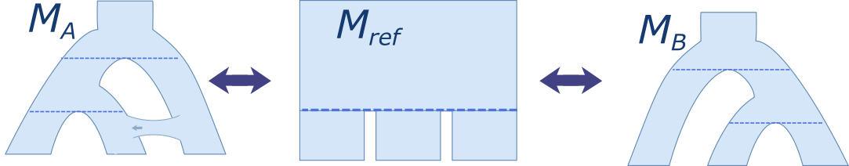

An example reference model Mref for comparing MA and MB

**Preliminary results –**

To show viability of the Relative Bayes Factors theory we’ve implemented a minimal model-comparison algorithm and testedit on a simple data set.

**Tests implementation and Setup**

For the tests we limited our choice of reference-models to models containing only a single ancestral population - $M_{root}$, as shown in figure 5.

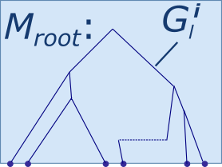

Fig 5 - The root reference Model Mroot

Formula [IV] is the genealogy likelihood calculation of Mroot under the Kingman Coalescent Model -

[IV]

$$T≔ \sum_{i in \left\{\begin{aligned}coalescence \\ events\end{aligned}\right\}}{\left(△_{i,i-1}Time\right)}\left(\#_{i}lineages\right)\left(\#_{i}lineages-1\right)$$

$$C≔ number of coalescence events$$

$$P\left(G|〈M_{root},Θ〉\right)=\prod_{Loci}{{\left(\frac{2}{θ_{root}}\right)}^{C}⋅\exp\left(\frac{-T}{θ_{root}}\right)}$$

We extended G-PhoCS to calculate sufficient statistics for Mroot, by having it emit only the aggregations of $C$ and $T$ across all loci in each iteration. This allowed us to later calculate $P\left(G|〈M_{root},Θ〉\right)$ for any $θ_{root}$.

For now we completely omitted likelihood of parameter priors - $P(Θ|M)$, to be handled later in our research. We calculated instead an altered version of formula [III] –

[V]

$${RBF'\left(M_{ref}, M\right)= Ε}_{GΘ|X,M}\left[\frac{P(G|〈M_{ref},Θ〉)}{P(G|〈M,Θ〉)}\right]$$

For the experiments we generated two sequence data-sets, X0 and X1, under models <M0, Θ>and <M1, Θ> respectively. M0:= Mroot is the model containing a single population named *root* and no divergences or migrations. The parameter of the model Θ0 is population size θ­root = 0.001. M1 is a model containing a single divergence from population *root* into populations $a$ and $b$ with no migration. Parameters Θ1 are population times $θ_{root}=θ_{a}=θ_{b}=0.001$ and divergence time $τ_{root}= 0.0001$ as shown in figure 6 –

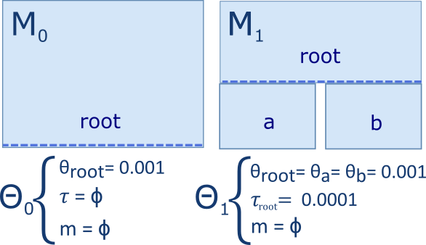

Fig 6 -Preliminary Models $〈M_{0},Θ_{0}〉$& $〈M_{1},Θ_{1}〉$

In both models we simulated genealogies over 16 samples (leaves). In M0 all samples belonged to the single population (root) and in M1 eight belonged to population *a* and eight to population *b*. Each data set contained 5,000 multiple sequence alignments of 16 sequences 1000 bases long.

Data was generated using standard tools; “ms” for generating data (genealogies or sequences) under the coalescence model (with recombination). “seq-gen” for simulating site-substitution models along genealogies [Hudson RR. 1991]. Two more custom scripts were used for running a simulation given an “ms” command line file and for converting the "seq-gen” output file to a G-PhoCS sequence input file.

In each experiment G-PhoCS was run for 50,000 iterations. For each iteration $P\left(G|〈M_{root},Θ〉\right)$ was calculated using formula [IV]. As θ­root we chose to use the G-PhoCS sampled value of θ­root, acquired from G-PhoCS trace output. For the expectation calculation, only the final 1000 samples were taken into account, this done to avoid using data sampled before the mcmc sampler reached the correct distribution - $[GΘ|X,M]$.

**Execution and Results**

We executed four simple experiments, each experiment characterized by its three inputs – sequence data, gphocs model and reference model - $〈X_{i}, M_{gphocs}, M_{ref}〉$. The reference model always stayed Mroot and the sequence data and gphocs model alternated.

In the table below are logarithm results of the four combinations of experiments. Table columns and rows represent respectively the sequence data and phylogenetic model on which gphocs ran. For example the bottom right corner holds the result of experiment - $〈X_{1}, M_{1}, M_{root}〉$:

|  |  |  |
| --- | --- | --- |
| $$\log{RBF'\left[M_{gphocs}, M_{ref}\right]}$$ | $$X_{0}$$ | $$X_{1}$$ |
| $$M_{0}$$ | $$1.41⋅{10}^{-4}$$ | $$1.44⋅{10}^{-5}$$ |
| $$M_{1}$$ | 11.55 | -57.12 |

The following is a summary of supporting data for each experiment:

* ***Experiment $<X_{0}, M_{0}, M_{root}>$***  -

This first experiment is a rudimentary sanity check of the model-comparison algorithm. Since both the training model and reference model equal the root model Mroot, we expect - $RBF'\left[M_{0}, M_{root}\right]= RBF'\left[M_{root}, M_{root}\right]=1 ⇒ \log{RBF'\left[M_{0}, M_{root}\right]}=0$. Our result comes close to zero as we expected - $\log{RBF'\left[M_{0}, M_{root}\right]}=1.41⋅{10}^{-4}$. The deviation from 0 is a result of the fact that we are computing $P[G, Θ |M_{root}]$ in two different ways and may stem from rounding errors in various stages of the algorithm. This will be addressed further in the research.

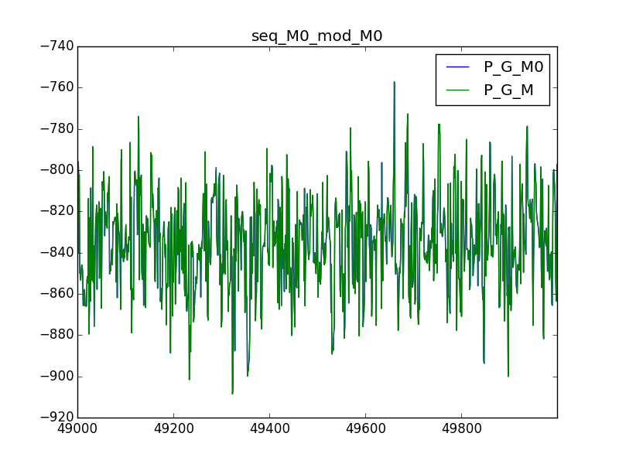

A plot of $\log{P\left(G | M_{0}\right)}$ and $\log{P\left(G | M_{root}\right)}$, sampled using X0, over G-PhoCS iterations. We see plots overlapping as expected since - $M_{0}=M_{1}=M_{root}$. This constitutes a sanity check of the algorithm. Inaccuracies stem from the two different calculation methods.

* ***Experiment $<X_{1}, M_{0}, M_{root}>$***  -

Again we expect - $RBF'\left[M_{0}, M_{root}\right]= RBF'\left[M_{root}, M_{root}\right]=1 ⇒ \log{RBF'\left[M_{0}, M_{root}\right]}=0$, as shown in the result $\log{RBF'\left[M_{0}, M_{root}\right]}=1.44{∙10}^{-5}$. Contrary to prediction, we see the choice of data *Xi* effected the result. Further examination is due.

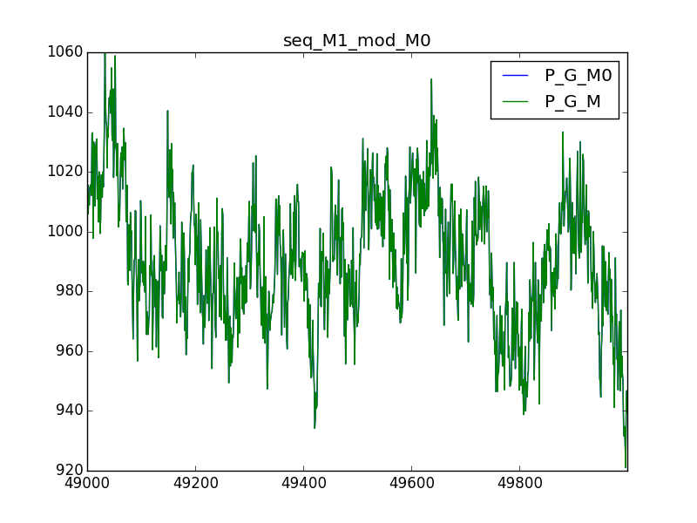

A plot of $logP\left(G | M_{0}\right)$ and $logP\left(G | M_{root}\right)$, sampled using X1, over G-PhoCS iterations.

* ***Experiment $<X_{0}, M_{1}, M_{root}>$***  -

Here we expect $P\left(G | M_{root}\right)> P\left(G | M_{1}\right) ⇒ Ε_{G|X,M}\left[\frac{P\left(G | M_{root}\right)}{P\left(G | M_{1}\right)}\right]>1 ⇒ \log{RBF'\left[M_{1},M_{root}\right]}>0$ and our result is $\log{RBF'\left[M_{0},M_{root}\right]}= 11.55$. The difference between likelihoods is small since during the G-PhoCS phase of the algorithm, the parameters of the training model M1 are fitted for sequence data *X0*, making it resemble Mroot by pushing the divergence time towards 0.

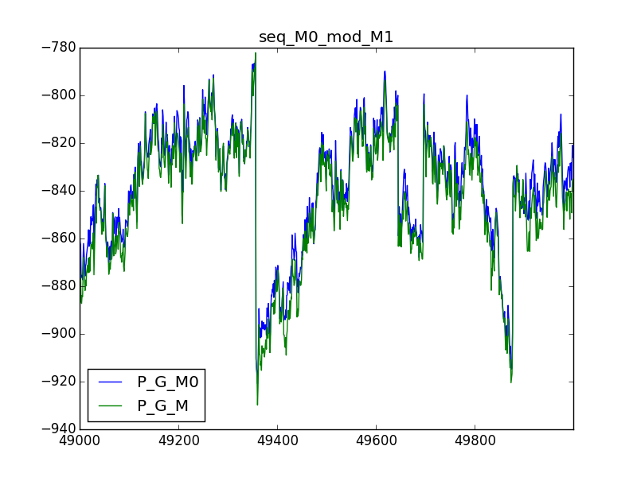

A plot of logP(G│M_1 ) and logP(G│M_root ), sampled using X0.

Estimated divergence time 𝜏root over gphocs iterations

* ***Experiment $<X_{1}, M_{1}, M_{root}>$***  -

Here we expect $P\left(G | M_{root}\right)< P\left(G | M_{1}\right) ⇒ Ε_{G|X,M}\left[\frac{P\left(G | M_{root}\right)}{P\left(G | M_{1}\right)}\right]<1 ⇒ \log{RBF'\left[M_{root},M_{1}\right]}<0$ and results confirm $\log{RBF'\left[M_{root},M_{1}\right]}= -57.12$. The preference for M1 is strong since, contrary to the previous experiment, the G-PhoCS phase didn’t bring the gphocs and reference models closer to one another. Results are larger than 0 likely since they are samples of a density function, however this assertion needs to be reasserted by further research.

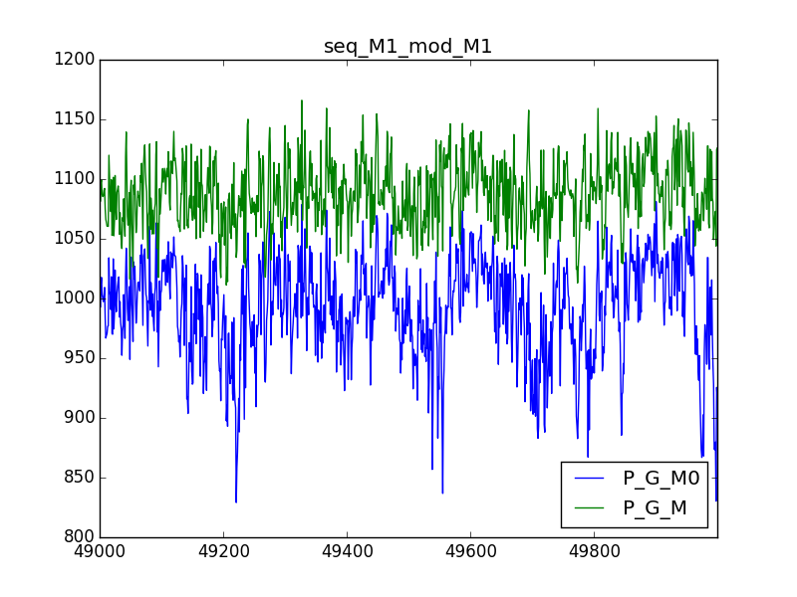

A plot of $logP\left(G | M_{1}\right)$ and $logP\left(G | M_{root}\right)$, sampled using X1.

**Future Work**

**Main objectives**

Our research project has three parts – theoretical, implementational and experimental.

The objectives of the theoretical part are to figure out formal limitations for the reference model and to address the issue of models with different complexity, i.e. different sets of parameters and genealogies with or without migration events.

In the implementational part we will continually expand the capabilities of G-PhoCS and Model-Comparison algorithms. We’ll extended the sufficient statistics which we now output for Mroot, to allow likelihood calculations for more complex, possibly arbitrary models. We’ll also solve the calculation inaccuracies, and perhaps add a reference-model selection phase.

In the experimental part we will continue work along the line we’ve set during the preliminary experiments phase, pushing forward each of the three dimensions of our experiments $〈X_{i}, M_{gphocs}, M_{ref}〉$. We will generate and acquire data-sets of new populations and phylogenies, and train and compare them on new models.

As the purpose of the experiments is to test the sensitivity of our algorithm and to demonstrate its capabilities, we’re currently considering two strategies for assessing performance; an analytical measurements of variance of the estimate of RBF, and a comparison to the Harmonic-Mean estimator as a current baseline.

Below are the tangible vectors in which our work will progress -

**1- Theoretical limitations of Mref**

The preliminary work has supplied for us a glimpse of possible results but it also accentuated the theoretical limitations of any reference model Mref. A primary goal of our research is then to formalize the “reference model” and its limitations: When calculating $RBF(M_{ref}, M)$, what are the hidden assumptions on Mref? What Criteria must Mref meet to uphold these assumptions?

For example, one such assumption would be that $P(GΘ |M_{ref})$ should be well-defined. When calculating $E[P(G|M_{ref})/ P(G|M)]$ we are actually estimating a discrete average over samples from an estimated space - $\left[GΘ|X,M\right]$. For some reference models, this estimation breaks; If some genealogy G1 in M1 has zero probability in Mref, then P(G1|Mref)/P(G1|M) = 0 and our estimation becomes useless.A Criteria to meet this assumption is therefore something of the sort – *“Let Mref be any population model which gives non-zero probability to all G in M1”*. The laying down and formalization of these assumptions and criteria is an initial and primary step in our research.

**2- Handling Parameter Priors**

One area which was overlooked during the preliminary work, but is of theoretical and practical importance, is the difference between model parameters prior likelihoods. These are taken into account in our expectation estimation -

$$RBF\left(M_{ref}, M\right)=Ε_{GΘ|X,M}\left[\frac{P(Θ|M_{ref})}{P(Θ|M)}∙\frac{P(G|Θ,M_{ref})}{P(G|Θ,M)}\right]$$

Different models M1, …, Mi as well as Mref are all structurally unique therefore they may contain different random variable parameters for population sizes, divergence times and migration rates (θ, 𝜏, m). Since priors are usually of the same gamma distribution, what matters however is mostly the number of different parameters |ΘM|, (|θ|, |𝜏|, |m|)M.

Currently, our preliminary algorithm completely ignores priors (formula [V] ). This is acceptable only under very limiting conditions such as |ΘM1| = |ΘM2|, because priors will reliantly cancel each other out. We must further explore and formalize our handling of priors: Under what assumptions may we ignore priors? How best to hand difference in priors between models without harming the correctness of model-comparison?

Another mile-stone in our work is to develop a theory and technique to map parameters from Mi to Mref in a way that satisfies [III], resulting in a legal Mref as described earlier. One idea for such a technique is to supplement models with “pseudo-parameters” – gamma distributed Random variables with no effect on the model - to equalize the number of parameters, then relying on the established algorithm for |ΘM1| = |ΘM2|. In our work we will drive to formalize and develop techniques for the handling of these parameters.

**3- Beyond the root reference model**

Our current preliminary algorithm supports only a root reference model Mroot. Though the model-comparison problem and probabilistic groundwork we have laid puts no restrictions on Mref, the efficiency of our algorithm relies on an execution of G-PhoCS on Mi, so we are bound to select only Mref whose likelihood calculation $P(G|M_{ref})$ is facilitated by said execution.

Our challenge is then to support as many reference models as possible. This challenge is split to the theoretical limitation, covered in previous subsection, and the practical limitations in extending G-PhoCS and the model-comparison post-processing phase. Throughout its execution, G-PhoCS maintains a complex and constantly updating set of data structures. The post-processing phase requires sufficient statistics regarding the sampling of the genealogies. Once we are decided on the theoretical bounds on Mref, we must implement a data structure plus algorithm to extract sufficient statistics from the G-PhoCS run-time.

Depending on the scope of supported reference models, these statistics may range from a complete snapshot of genealogies across all loci in every iteration, through aggregating statistics for each major event in the model (such as population split, migration band start, etc.) all the way to a single precomputed likelihood value for some specific reference model, similar to the one computed in our preliminary algorithm.

The development and implementation of these data structures and algorithms will be one of the first and possibly largest ongoing challenge we will meet in the course of our research.

**4- Choosing a reference model**

Once we have enabled calculating model-comparison using different reference models, we can now point our attention towards recommending the best one for a specific comparison. Formalizing and implementing an approach to finding the best Mref is necessary to make model-compare useful in real-world scenarios. The choice of a reference model can will influence the efficiency of estimation, making the difference between a quickly converging, high confidence, usable algorithm and an unreliable, very long-running algorithm (as described in the discussion about harmonic mean).

This is an advanced but rewarding part of our research. We will first describe a scoring function for the compatibility of Mref to the model-comparison question between Mi and Mj. Denote this function $S_{i,j}(M_{ref})$. We will rely on this function and suggest an algorithm to find an optimal Mref, one which maximizes $S_{i,j}(M_{ref})$.

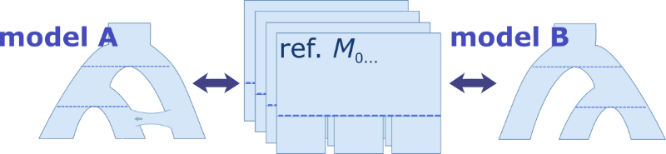

Choosing an optimal reference model

**Parameter Priors**

The Issue with parameter priors begins when examining the RBF formula [III]